

Submitted By:
MUHAMMAD ZAIN RASHEED
2025-CYS-153
Assignment:
Lab No.5
Submitted To:
Sir Mubashir

For the fulfillment of,
Object-Oriented Programming Lab
Department of Computer Engineering

University of Engineering and Technology, Lahore

Task 1: Design and implement a class dayType that implements the day of the week in a program.The class dayType should store the day, such as Sun for Sunday. The program should be able to perform the following operations on an object of type dayType. Solution: public class lab5{ public class dayType{
String[] 𝑑𝑎𝑦𝑠 = {^{𝑛}𝑆𝑢𝑛^{𝑛},^{𝑛} 𝑀𝑜𝑛^{𝑛},^{𝑛} 𝑇𝑢𝑒𝑆^{𝑛},^{𝑛} 𝑀𝑒𝑑^{𝑗𝑛},^{𝑛} 𝑇ℎ𝑢𝑟𝑠^{𝑛},^{𝑛} 𝐹𝑟𝑖^{𝑛},^{𝑛} 𝑆𝑎𝑡^{𝑛}}; int
number; public dayType(String startDay){ setDay(startDay);
｝ public void setDay(String day){了
for (inti=0;i<=7;i++λ if
(days[i].equals(day)){
number=i;
break;

了

了
}
public void printDay(){
System.out.println(days[number]);
}
public String getDay(){ return days[number];
}
public String nextDay(){ return days[(number+1)%7];
}
public String previousDay(){
return days[(number+6)%7];
}
public String addDays(int added number){
return days[(number+added number)%7];
}
}
public void main(String[]args){

dayType today=new dayType("Mon");
today.printDay();
System.out.println(today.addDays(4));
System.out.println(today.previousDay( ));
}
}
output:

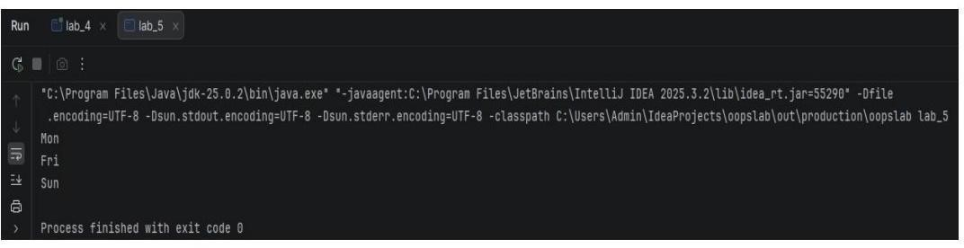
Lab task 2: Walls has decided that they are going to sell their ice cream in 7 different flavors namely chocolate, vanilla, strawberry, mango, tutti fruit, almond crunch, and coffee. Solution:

class Walls{
String flavor; int numScoops;
String coneType; double price;

public Walls(){
this("Vanilla",1,"𝑆𝑢𝑔𝑎𝑟′′);

public Walls(String flavor, int numScoops, String coneType){
this.flavor=flavor; this.numscoops=numscoops;
this.coneType=coneType; this.price
=calculatePrice ();

private double calculatePrice(){
double total= numScoops* 75.0; if

(coneType.equalslgnoreCase("Waffle")){ tota|+=40.0;
}
return total;
}

public void displayBill(){
System.out.println("\n--- Order Receipt ---");
System.out.println("Flavor: "+flavor);
System.out.println("Scoops:"+ numScoops);
System.out.println("Cone: ′′ +cos⁡(𝑦𝑝𝑒);

System.out.println("Total: Rs. " + price);
System.out.println(" --------------------------- ");
}
}

public static void main(String[] args){
Scanner input=new Scanner(System.in);

System.out.println("Flavors: Chocolate, Vanilla, Strawberry, Mango, Tutti Fruit, Almond Crunch, Coffee");

System.out.print("Enter flavor: ");
String flnput=input.nextLine();

System.out.print("Enter number of scoops: ");
String slnput=input.nextLine();

System.out.print("Enter cone type: ");
String clnput=input.nextLine();
Walls order;

if (flnput.isEmpty() && sInput.isEmpty() && clnput.isEmpty()){
order=newwwalls();
}else{

String finalFlavor; if (flnput.isEmpty()){ f∈alF|avor="Vanil|a";
}else{ finalFlavor=flnput;
}
int finalScoops;
if (slnput.isEmpty()){ finalScoops=1;
}else{ finalScoops=Integer.parselnt(slnput);

String finalCone; if (clnput.isEmpty()){
𝑓 ∈ 𝑎𝑙𝐶𝑜𝑛𝑒 = "𝑆𝑢𝑔𝑎𝑟′′;
}else{ f∈alCone=clnput;
}

order=newWalls(finalFlavor, finalScoops, finalCone);
}
order.displayBill();

} 了
Output:

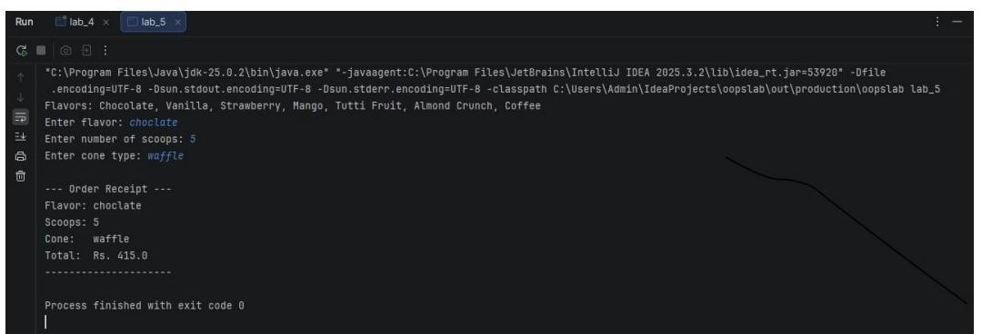
Task no 3: Create a class by the named Product. Create the following private members name(String), price(int) and quantity(int). · Define a parameter-less and a parameterized constructor. · Define the following member functions.·void getDataconstructor.·Define the following member functions.·void
getData()·static void counter() () ·
static int countProduct()·The class would contain a static int 'totalProduct', having initial value equal to zero.·Each time an instance of the product class is created, the 'counter ()' should be called. The 'counter ()' increments the static member by 1 value.
Suppose I create 5 products, when I execute the following code it should display 5.
Solution: public class
Product{ private
String name; private int price; private int quantity;

private static int totalProduu=0

public Product(){ this.name="Unknown";
this.price=0; this.quantity
=0; counter();

public Product(String name, int price, int quantity) { this.name=name;
this.price=price; this.quantity=quantity; cotter();
}

public static void counter(){ totalProduct++;
}

public static int countProduct(){ return totalProduct;

public void getData(){
System.out.println("Product:"+name+"|Price:"+price+"|Quantity:"+quantity);1

public static void main(String[] args){
Product𝑝1 = 𝑛𝑒𝑤𝑝𝑟𝑜𝑑𝑢𝑐𝑡𝑙′′𝐿𝑎_ptop",1200,5);
𝑃𝑟𝑜𝑑𝑢𝑐𝑡𝑝2 = 𝑛𝑒𝑤𝑃𝑟𝑜𝑑𝑢𝑐𝑡(′′𝑀𝑜𝑢𝑠𝑒′′, 25,10);
Productp3=newproduct();
𝑃𝑟𝑜𝑑𝑢𝑐𝑡𝑝4 = 𝑛𝑒𝑤𝑃𝑟𝑜𝑑𝑢𝑐𝑡𝑙¹¹𝐾𝑒𝑦𝑏𝑜𝑎𝑟𝑑¹¹,45,20); Product𝑝5
= 𝑛𝑒𝑤𝑃𝑟𝑜𝑑𝑢𝑐𝑡(¹¹𝑀𝑜𝑛𝑖𝑡𝑜𝑟¹¹,300,10);
System.out.println(Product.countProduct());
output:

